A WEB-BASED STUDENT AND TEACHER PORTAL FOR ACADEMIC MANAGEMENT
Project Phase-I Report submitted to Osmania University, Hyderabad, in partial fulfillment of the requirement for the award of the degree of
Bachelor of Engineering
in
Information Technology

By

Mr. Ismail Fazal Mahmood Khan (160923737037)
Mr. Gulam Mohammed (160923737047)
Mr. Mohammed Adeeb ur Rahman (160923737060)

Under the Guidance of
Mr. Siva Rama Krishna
Assistant Professor


DEPARTMENT OF INFORMATION TECHNOLOGY

LORDS INSTITUTE OF ENGINEERING AND TECHNOLOGY

(UGC Autonomous)

(Affiliated to Osmania University)
Himayathsagar, Hyderabad,500091

A.Y. 2026-2027

LORDS INSTITUTE OF ENGINEERING AND TECHNOLOGY
(UGC Autonomous)
(Affiliated to Osmania University)
Himayathsagar, Hyderabad, 500091
Department of Information Technology

CERTIFICATE
This is to certify that the Project Phase-I report entitled A WEB-BASED STUDENT AND TEACHER PORTAL FOR ACADEMIC MANAGEMENT being submitted by Mr. Ismail Fazal Mahmood Khan (160923737037), Mr. Gulam Mohammed (160923737047), Mr. Mohammed Adeeb ur Rahman (160923737060) in partial fulfillment of the requirements for the award of the degree of Bachelor of Engineering in Information Technology is a record of Bonafide work carried out by them.

Internal Project Guide: Head of the Department
Mr. Siva Rama Krishna Dr. K. Nagi Reddy
Assistant Professor
External Examiner

LORDS INSTITUTE OF ENGINEERING AND TECHNOLOGY
(UGC Autonomous)
(Affiliated to Osmania University)
Himayathsagar, Hyderabad, 500091
Department of Information Technology

DECLARATION BY THE CANDIDATES

We, Mr. Ismail Fazal Mahmood Khan (160923737037), Mr. Gulam Mohammed (160923737047) and Mr. Mohammed Adeeb ur Rahman (160923737060), hereby declare that the Project Phase-I report entitled A WEB-BASED STUDENT AND TEACHER PORTAL FOR ACADEMIC MANAGEMENT is carried out under the guidance of Mr. Siva Rama Kirshna, Assistant Professor, Department of Information Technology, Lords Institute of Engineering and Technology, Hyderabad is submitted in partial fulfillment of the requirements for the award of the degree of Bachelor of Engineering in Information Technology.

This is a record of bonafide work carried out by us and the results embodied in this project have not been reproduced or copied from any source. The results embodied in this project report have not been submitted to any other university or institute for the award of any other degree or diploma.

Ismail Fazal Mahmood Khan (160923737037)
Gulam Mohammed (160923737047)
Mohammed Adeeb ur Rahman (160923737060)

ACKNOWLEDGMENT

We are very pleased to present this thesis of our project. This period of our student life has been truly rewarding a number of people were of immense help to us during the course of our research and the preparation of our thesis.

First, we wish to thank GOD Almighty who created heavens and earth, who helped us in completing this project and we also thank our parents who encouraged us in this period of research.

We would like to express our sincere gratitude to The Management of Lords Institute of Engineering and Technology, Hyderabad for providing us with an excellent platform and resources to successfully carry out this project.

We would also like to thank Dr. Ravi Kishore Singh, Principal, L.I.E.T. for extending his help in overall completion of this project work.

We would like to express my deep sense of gratitude to Dr. K. Nagi Reddy, Professor & HOD, Information Technology, Lords Institute of Engineering & Technology, Hyderabad, for his encouragement and cooperation throughout the project.

We would like to thank Mr. Siva Rama Krishna , Assistant Professor, Dept. of Information Technology, Lords Institute of Engineering & Technology, Hyderabad, our project internal guide, for his guidance and help. His insight during the course of our research and regular guidance were invaluable to us.

Lastly, we acknowledge the support of our faculty members, friends, and family, who inspired and encouraged us throughout this journey.

Ismail Fazal Mahmood Khan (160923737037)
Gulam Mohammed (160923737047)
Mohammed Adeeb ur Rahman (160923737060)


LORDS INSTITUTE OF ENGINEERING &TECHNOLOGY
Approved by AICTE/Affiliated to Osmania University/Estd.2003.
Accredited ‘A’ grade by NAAC
(UGC Autonomous Institution)

Vision of the Institute
Lords Institute of Engineering and Technology strives for excellence in professional education through quality, innovation and teamwork and aims to emerge as a premier institute in the state and across the nation.
Mission of the Institute
- To impart quality professional education that meets the needs of present and emerging technological world.
- To strive for student achievement and success, preparing them for life, career and leadership.
- To provide a scholarly and vibrant learning environment that enables faculty, staff and students to achieve personal and professional growth.
- To contribute to advancement of knowledge, in both fundamental and applied areas of engineering and technology.
- To forge mutually beneficial relationships with government organizations, industries, society and the alumni.


LORDS INSTITUTE OF ENGINEERING &TECHNOLOGY
Approved by AICTE/Affiliated to Osmania University/Estd.2003.
Accredited ‘A’ grade by NAAC
(UGC Autonomous Institution)

DEPARTMENT OF INFORMATION TECHNOLOGY

Vision of the Department:
To be a frontier in Information Technology focusing on quality professional education, innovation and employability.
Mission of the Department:
DM1: Adopt innovative teaching learning processes to achieve stated outcomes and sustained performance levels.
DM2: Provide learner centric environment to enrich knowledge, skills and innovation through industry academia collaborations.
DM3: Train the concerned stakeholders on latest technologies to meet the industry needs.
DM4: Inculcate leadership, professional, interpersonal skills and ethical values to address the contemporary societal issues.
Note: DM: Department Mission

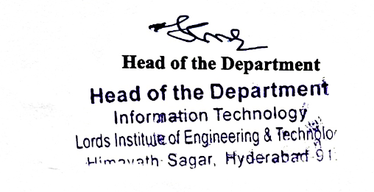

LORDS INSTITUTE OF ENGINEERING &TECHNOLOGY
Approved by AICTE/Affiliated to Osmania University/Estd.2003.
Accredited ‘A’ grade by NAAC
(UGC Autonomous Institution)

DEPARTMENT OF INFORMATION TECHNOLOGY

B.E Information Technology Program Educational Objectives (PEOs):

PEO1 | Be a competent software engineer in IT and allied industry providing viable solutions.
PEO2 | Exhibit professionalism, engage in lifelong learning and adopt to changing industry and societal needs.
PEO3 | Be effective as an individual and also cohesive in a group to execute multidisciplinary projects.
PEO4 | Pursue higher studies in Information Technology with emphasis on competency and innovation.

LORDS INSTITUTE OF ENGINEERING &TECHNOLOGY
Approved by AICTE/Affiliated to Osmania University/Estd.2003.
Accredited ‘A’ grade by NAAC
(UGC Autonomous Institution)

DEPARTMENT OF INFORMATION TECHNOLOGY

B.E Information Technology Program Outcomes (POs):
Engineering Graduates will be able to:
S. No. | Program Outcomes (POs)
1. | PO1: Engineering Knowledge: Apply knowledge of mathematics, natural science, computing, engineering fundamentals and an engineering specialization as specified in WK1 to WK4 respectively to develop to the solution of complex engineering problems.
2. | PO2: Problem Analysis: Identify, formulate, review research literature and analyze complex engineering problems reaching substantiated conclusions with consideration for sustainable development. (WK1 to WK4)
3. | PO3: Design/Development of Solutions: Design creative solutions for complex engineering problems and design/develop systems/components/processes to meet identified needs with consideration for the public health and safety, whole-life cost, net zero carbon, culture, society and environment as required. (WK5)
4. | PO4: Conduct Investigations of Complex Problems: Conduct investigations of complex engineering problems using research-based knowledge including design of experiments, modelling, analysis & interpretation of data to provide valid conclusions. (WK8).
5. | PO5: Engineering Tool Usage: Create, select and apply appropriate techniques, resources and modern engineering & IT tools, including prediction and modelling recognizing their limitations to solve complex engineering problems. (WK2 and WK6)
6. | PO6: The Engineer and The World: Analyze and evaluate societal and environmental aspects while solving complex engineering problems for its impact on sustainability with reference to economy, health, safety, legal framework, culture and environment. (WK1, WK5, and WK7).
7. | PO7: Ethics: Apply ethical principles and commit to professional ethics, human values, diversity and inclusion; adhere to national & international laws. (WK9)
8. | PO8: Individual and Collaborative Team work: Function effectively as an individual, and as a member or leader in diverse/multi-disciplinary teams.
9. | PO9: Communication: Communicate effectively and inclusively within the engineering community and society at large, such as being able to comprehend and write effective reports and design documentation, make effective presentations considering cultural, language, and learning differences
10. | PO10: Project Management and Finance: Apply knowledge and understanding of engineering management principles and economic decision-making and apply these to one’s own work, as a member and leader in a team, and to manage projects and in multidisciplinary environments.
11. | PO11: Life-Long Learning: Recognize the need for, and have the preparation and ability for i) independent and life-long learning ii) adaptability to new and emerging technologies and iii) critical thinking in the broadest context of technological change. (WK8)

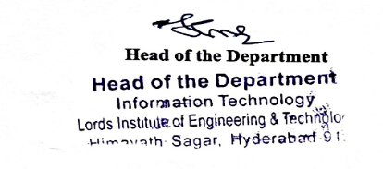
LORDS INSTITUTE OF ENGINEERING &TECHNOLOGY
Approved by AICTE/Affiliated to Osmania University/Estd.2002.
Accredited ‘A’ grade by NAAC
(UGC Autonomous Institution)

DEPARTMENT OF INFORMATION TECHNOLOGY

B.E Information Technology Program Specific Outcomes (PSOs):

PSO1 | Professional Skills: Identify, analyze requirements, design and implement computer programs in the area of artificial intelligence, machine learning, big data analytics and networking of varying complexity.
PSO2 | Problem-Solving Skills: Deliver quality service to IT industry and provide solutions to real-life problems applying modern computer languages, software methods and tools.

LORDS INSTITUTE OF ENGINEERING &TECHNOLOGY
Approved by AICTE/Affiliated to Osmania University/Estd.2002.
Accredited ‘A’ grade by NAAC
(UGC Autonomous Institution)

DEPARTMENT OF INFORMATION TECHNOLOGY

Course Outcomes: Project Phase- I
After completion of the project, the student will be able to
S.No | Description | Blooms Taxonomy Level
PP.I.CO1 | Demonstrate the ability to synthesize and apply the knowledge and skills acquired in the academic program to the real-world problems. | BTL3
PP.I.CO2 | Evaluate different solutions based on economic and technical feasibility | BTL4
PP.I.CO3 | Effectively plan a project and confidently perform all aspects of project management. | BTL5
PP.I.CO4 | Demonstrate effective written and oral communication skills | BTL4
PP.I.CO5 | Prepare the documentation report and perform the presentation of the project work | BTL3

LORDS INSTITUTE OF ENGINEERING &TECHNOLOGY
Approved by AICTE/Affiliated to Osmania University/Estd.2002.
Accredited ‘A’ grade by NAAC
(UGC Autonomous Institution)
DEPARTMENT OF INFORMATION TECHNOLOGY
Course Articulation Matrix:
Course Outcomes (COs) | Program Outcomes (POs) |  |  |  |  |  |  |  |  |  |  | Program Specific Outcomes  (PSOs)
 | PO1 | PO2 | PO3 | PO4 | PO5 | PO6 | PO7 | PO8 | PO9 | PO10 | PO 11 | PSO1 | PSO2
PP.I.CO1 | 3 | 2 | 2 | - | 2 | 2 | - | - | 3 | - | - | 2 | 2
PP.I.CO2 | 3 | 3 | 2 | 3 | 2 | - | 2 | - | 3 | - | - | - | 2
PP.I.CO3 | 3 | 3 | 3 | - | 3 | 3 | 1 | 2 | 2 | 3 | 2 | 3 | -
PP.I.CO4 | 3 | 2 | 2 | 3 | 3 | 3 | 3 | 2 | - | - | 2 | 3 | 3
PP.I.CO5 | 3 | 3 | 3 | 3 | 3 | 3 | 3 | 2 | 3 | 3 | - | 3 | 3
AVG | 3 | 2.6 | 2.5 | 3 | 2.6 | 2.7 | 2.2 | 2 | 2.9 | 3 | 2 | 2.7 | 2.5
Mapping of Course Outcomes (COs) with Program Outcomes (POs) and Program Specific Outcomes (PSOs):
Level:
Low correlation (Low), 2- Medium correlation (Medium), 3-High correlation (High)
SDG Mapping:
SDG | Mapped Indicator | SDG | Mapped Indicator | SDG | Mapped Indicator
 |  |  |  | 
 |  |  |  | 
 |  |  |  | 
 |  |  |  | 
 |  |  |  | 
 |  | 

ABSTRACT

In the proposed work, a centralized Student Portal is proposed to streamline academic performance tracking for students and faculty members using Machine Learning techniques. The system leverages historical student marks data to train two predictive models: Naïve Bayes and XGBoost. These models provide real-time performance feedback for students based on their subject-wise marks. The portal includes dedicated dashboards for Admin, Teachers, and Students, enabling key functionalities such as attendance tracking, assignment management, study material sharing, performance analysis, and direct communication between stakeholders. The XGBoost model is expected to deliver superior accuracy, making it a robust tool for academic performance prediction and personalized feedback generation.
Keywords: Student Performance Prediction, Machine Learning, Naïve Bayes, XGBoost, Academic Analytics, Centralized Student Portal, Predictive Feedback System

CONTENTS

Certificate i
Declaration ii
Acknowledgement iii
Vision and Mission of the Institute iv
Vision and Mission of the Department v
Program Educational Objectives vi
Program Outcomes vii
Program Specific Outcomes viii
Course Outcomes ix
Course Articulation Matrix xi
Abstract xii
Contents xiii
List of Figures xv
List of Tables xvi
CHAPTER-1: INTRODUCTION 1
1.1 Introduction 1
1.2 Objectives 1
CHAPTER-2: LITERATURE SURVEY 2
2.1 E-Learning System using the DSDM Approach 2
2.2 LMS Design Focusing on Emotional Aspects 2
2.3 E-Learning Implementation at Tripoli University 2
2.4 Relational Database for Learning Management Systems 2
2.5 E-Learning in Resource-Constrained Countries 3
2.6 E-Learning Systems in Technical Universities 3
2.7 System Development Approach for E-Learning Requirements 3
2.8 E-Learning at the University of Gezira 3
CHAPTER-3: SYSTEM ANALYSIS AND REQUIREMENTS 4
3.1 Existing System 4
3.2 Proposed System 4
3.3 System Architecture 5
3.4 Modules Description 6
3.5 Software Requirement Specification 8
3.5.1 Overall Description 8
3.5.2 External Interface Requirements 8
3.5.3 System Requirements 9
CHAPTER-4: SYSTEM STUDY AND DESIGN 10
4.1 Feasibility Study 10
4.1.1 Economic Feasibility 10
4.1.2 Operational Feasibility 10
4.1.3 Technical Feasibility 10
4.2 Software Development Life Cycle (Umbrella Model) 10
4.3 UML Diagrams 16
4.3.1 Class Diagram 16
4.3.2 Use Case Diagram 16
4.3.3 Sequence Diagram 18
4.3.4 Collaboration Diagram 19
4.3.5 Component Diagram 20
4.3.6 Deployment Diagram 22
4.3.7 Activity Diagram 23
4.3.8 Data Flow Diagram 24
CHAPTER-5: INPUT AND OUTPUT DESIGN 26
5.1 Input Design 26
5.2 Output Design 27
CHAPTER-6: SOFTWARE ENVIRONMENT 28
CHAPTER-7: SYSTEM TESTING AND RESULTS DISCUSSION 29
7.1 System Testing 29
7.1.1 System Testing Table 29
7.2 Results Discussion 29
CHAPTER-8: CONCLUSION 31
CHAPTER-9: FUTURE ENHANCEMENTS 32
REFERENCES 32
List of Figures
SI.no | Fig.no | Name of the Figure | Page No
1 | 3.1 | System Architecture | 5
2 | 4.1 | SDLC Umbrella Model | 10
3 | 4.2 | Requirements Definition Stage | 11
4 | 4.3 | Planning Stage | 12
5 | 4.4 | Design Stage | 13
6 | 4.5 | Development Stage | 14
7 | 4.6 | Integration and Test Stage | 14
8 | 4.7 | Installation and Acceptance Stage | 15
9 | 4.8 | Class Diagram | 16
10 | 4.9 | Use Case Diagram – Admin | 17
11 | 4.10 | Use Case Diagram – Teacher | 17
12 | 4.11 | Use Case Diagram – Student | 17
13 | 4.12 | Sequence Diagram – Admin | 18
14 | 4.13 | Sequence Diagram – Teacher | 18
15 | 4.14 | Sequence Diagram – Student | 19
16 | 4.15 | Collaboration Diagram – Admin | 19
17 | 4.16 | Collaboration Diagram – Teacher | 20
18 | 4.17 | Collaboration Diagram – Student | 20
19 | 4.18 | Component Diagram – Admin | 21
20 | 4.19 | Component Diagram – Teacher | 21
21 | 4.20 | Component Diagram – Student | 21
22 | 4.21 | Deployment Diagram – Admin | 22
23 | 4.22 | Deployment Diagram – Teacher | 22
24 | 4.23 | Deployment Diagram – Student | 23
25 | 4.24 | Activity Diagram – Admin | 23
26 | 4.25 | Activity Diagram – Teacher | 24
27 | 4.26 | Activity Diagram – Student | 24
28 | 4.27 | Data Flow Diagram – Admin | 25
29 | 4.28 | Data Flow Diagram – Teacher | 25
30 | 4.29 | Data Flow Diagram – Student | 25

List of Tables
SI.no | Table.no | Name of the Table | Page No
1 | 3.1 | Hardware Requirements | 9
2 | 3.2 | Software Requirements | 9
3 | 5.1 | Role-wise Inputs and Outputs | 27
4 | 7.1 | System Test Cases | 29

CHAPTER-1
INTRODUCTION

1.1 Introduction
This project designs a centralized web-based portal for the academic management of students and teachers, with role-based access (Admin, Teacher, Student) and Machine Learning to predict student performance from marks data.

1.2 Objectives
The main objectives of the proposed work are:
- To develop a centralized student portal that integrates academic, administrative, and communication functionalities for students, teachers, and administrators.
- To implement Machine Learning models specifically Naïve Bayes and XGBoost to accurately predict student academic performance based on historical marks data.
- To provide real-time performance feedback for students to support personalized learning, self-improvement, and early identification of academic risks.
- To enhance campus-wide academic workflows by enabling attendance tracking, assignment management, study material sharing, and structured communication between stakeholders.
- To achieve high-accuracy prediction results, utilizing the XGBoost model’s superior performance to deliver predictions with over 93% accuracy, ensuring reliable academic analytics within the portal.

CHAPTER-2
LITERATURE SURVEY
This chapter reviews earlier research on e-learning systems and LMS in higher education.

2.1 E-Learning System using the DSDM Approach
“Developing E-Learning System to Support Teaching and Learning Activities Using DSDM Approach, Performa”
A.K. Prewar, T. D. Sofianti and d. Y. Indrayadi (2015).
An e-learning system (Moodle) built using DSDM improved teaching and learning and was well accepted by users.

2.2 LMS Design Focusing on Emotional Aspects
“E-learning System Design by Learning Management System (LMS) focusing on Emotional Aspects using Biological Signals”
M Kura (2013).
An LMS design that detects learners' emotions from biological signals to improve e-learning effectiveness.

2.3 E-Learning Implementation at Tripoli University
“Improving the Effectiveness of E-Learning Implementation in the School of Engineering at Tripoli”
K Thuraya (2015).
Identified technical, cultural and management barriers to e-learning; a blended learning package improved teaching quality.

2.4 Relational Database for Learning Management Systems
“Development of a relational database for learning management systems”
O Deperlioglu (2011).
A SCORM-compliant relational database design for managing LMS academic and administrative processes.

2.5 E-Learning in Resource-Constrained Countries
“Lessons Learned from Implementing E-Learning for the Education of Health Professionals in Resource-Constrained Countries”
M Gupta and S arsden (2018).
Suitable ICT infrastructure and bandwidth management are crucial for e-learning in resource-constrained countries.

2.6 E-Learning Systems in Technical Universities
“Development of E-learning systems in technical universities”
G Musca and Andrei and Lucian (2018).
E-learning is growing rapidly in technical universities and helps improve traditional education systems.

2.7 System Development Approach for E-Learning Requirements
“Applying a System Development Approach to Translate Educational Requirements into ELearning”
S Hadjerroui (2017).
A systematic development approach is needed to turn educational requirements into effective e-learning systems.

2.8 E-Learning at the University of Gezira
“Implementation of Elearning in The University of Gezira Barriers and Opportunities”
A allaIdris and Y Osman (2017).
Lack of infrastructure and training were the main barriers to e-learning adoption, though staff attitude was positive.

CHAPTER-3
SYSTEM ANALYSIS AND REQUIREMENTS

3.1 Existing System
Existing systems offer only basic attendance, results and messaging; they are manual, fragmented and cannot predict student outcomes.
Disadvantages
- Lacks predictive analysis for student performance; decisions are based solely on past grades.
- Inefficient communication channels between students, faculty, and parents.
- Manual record maintenance increases the risk of data inconsistency and errors.

3.2 Proposed System
The proposed portal provides Admin, Teacher and Student dashboards for managing records, attendance, assignments, materials and marks, and uses Naïve Bayes and XGBoost to classify performance as Good, Fair or Poor.
Advantages
- Integrates machine learning algorithms (XGBoost and Naïve Bayes) for accurate academic performance prediction.
- Provides centralized dashboards for streamlined management of students

3.3 System Architecture
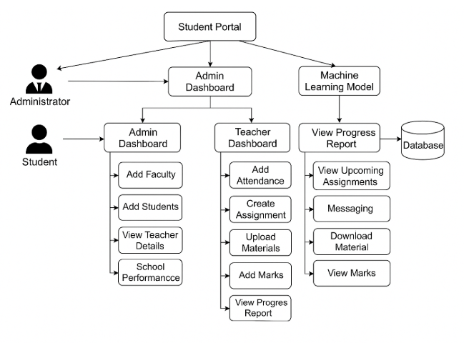
Fig 3.1 System Architecture

3.4 Modules Description
To implement this project, we have designed following modules:
Admin Dashboard
1) Admin Login: admin can login to system using username and password as admin and admin. After login admin will perform following activities
2) Add Faculty Details: after login admin can add new teacher details by utilising this module
3) Add Students Details: can add new students details
4) View Teacher Details: can view list of all existing teacher details
5) View Student Details: can view list of all existing students details
6) School Performance: can view performance of all teachers based on average grades obtained by student’s under that teacher
Teacher Dashboard
1) Teacher Login: teacher can login to system using username and password given by admin:
2) Add Attendance: can add attendance of student’s
3) Create Assignment: can create new task or assignment details
4) Upload Materials: can upload and share study material with students
5) Add Marks: can add students marks subject wise
6) Messaging: can send messages to students and parents and all messages will be send to parent EMAIL
7) View Progress Report: can view grades and marks for each students and feedback predicted by ML algorithm
8) View Student Messages: can view messages posted by students
Student Dashboard
1) Student Login: can login to system using username and password given by admin
2) View Upcoming Assignments: can view new upcoming assignment task details
3) Messaging: can post doubts or messages to teacher
4) Download Material: can view list of material uploaded by teacher and can download desired material
5) View Marks: can view marks for all subjects and can get feedback predicted by ML
6) View Messages: can view messages sent by teacher.

3.5 Software Requirement Specification

3.5.1 Overall Description

The Student Portal is a web-based academic management system that connects administrators, teachers and students on one platform. The Admin manages faculty and student records, teachers manage attendance, assignments, study materials and marks, and students view their marks, materials and feedback. The system also uses Naïve Bayes and XGBoost models to predict student performance as Good, Fair or Poor from the marks data. It runs in a web browser on ordinary hardware and is built with Python and Django.
3.5.2 External Interface Requirements
User Interface
The user interface of this system is a user friendly python Graphical User Interface.
Hardware Interfaces
The interaction between the user and the console is achieved through python capabilities.
Software Interfaces
The required software is python.

3.5.3 System Requirements
Table 3.1 Hardware Requirements
Component | Minimum Requirement
Processor | Intel i3 (minimum)
Speed | 1.1 GHz
RAM | 4 GB (minimum)
Hard Disk | 500 GB (minimum)
Table 3.2 Software Requirements
Component | Requirement
Operating System | Windows 10 or above
Programming Language | Python 3.7.0 with Django

CHAPTER-4
SYSTEM STUDY AND DESIGN

4.1 Feasibility Study
The system is checked for technical, operational and economic feasibility.

4.1.1 Economic Feasibility
It uses existing hardware and open technologies.

4.1.2 Operational Feasibility
It meets user requirements, so little resistance to adoption is expected.

4.1.3 Technical Feasibility
It is built with Python and Django on ordinary hardware, SDLC is nothing but Software Development Life Cycle.
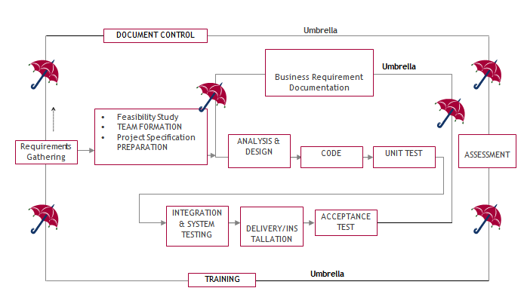
Fig 4.1 SDLC Umbrella Model
Stages in SDLC:
1) Requirement Gathering
2) Analysis
3) Designing
4) Coding
5) Testing
6) Maintenance
Requirements Gathering Stage
The project goals are refined into requirements that define the major functions, data and user classes of the portal. The output is the requirements document.
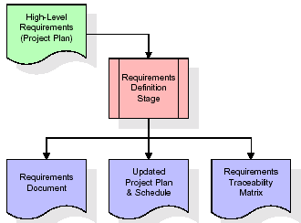
Fig 4.2 Requirements Definition Stage
Analysis Stage
The planning stage gives an overview of the product, evaluates feasibility and risks, and produces the project plan and schedule.
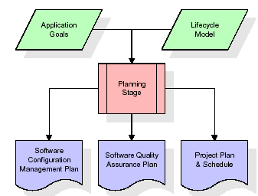
Fig 4.3 Planning Stage
Designing Stage
Each requirement is converted into design elements such as screen layouts, business rules, process diagrams and the entity-relationship diagram.
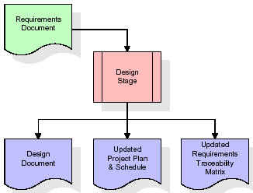
Fig 4.4 Design Stage

Development (Coding) Stage
The design is coded into software artifacts such as menus, forms, reports and procedures, together with test cases.
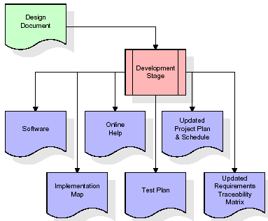
Fig 4.5 Development Stage
Integration & Test Stage
The software is moved to a test environment, where all test cases are run to verify its correctness and completeness.
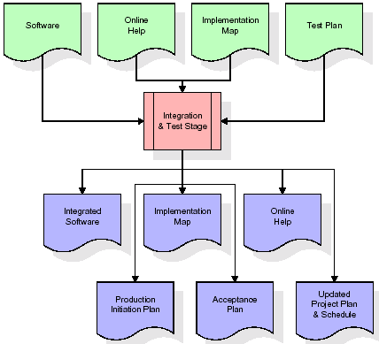
Fig 4.6 Integration and Test Stage
Installation & Acceptance Test
The software is installed on the production server and tested, and the customer formally accepts it after successful verification.
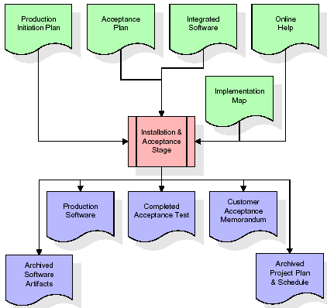
Fig 4.7 Installation and Acceptance Stage
Maintenance
Maintenance continues throughout the life of the project, like an umbrella with no end point.

4.3 UML Diagrams
4.3.1 Class Diagram
The class diagram shows the classes with their attributes and methods.
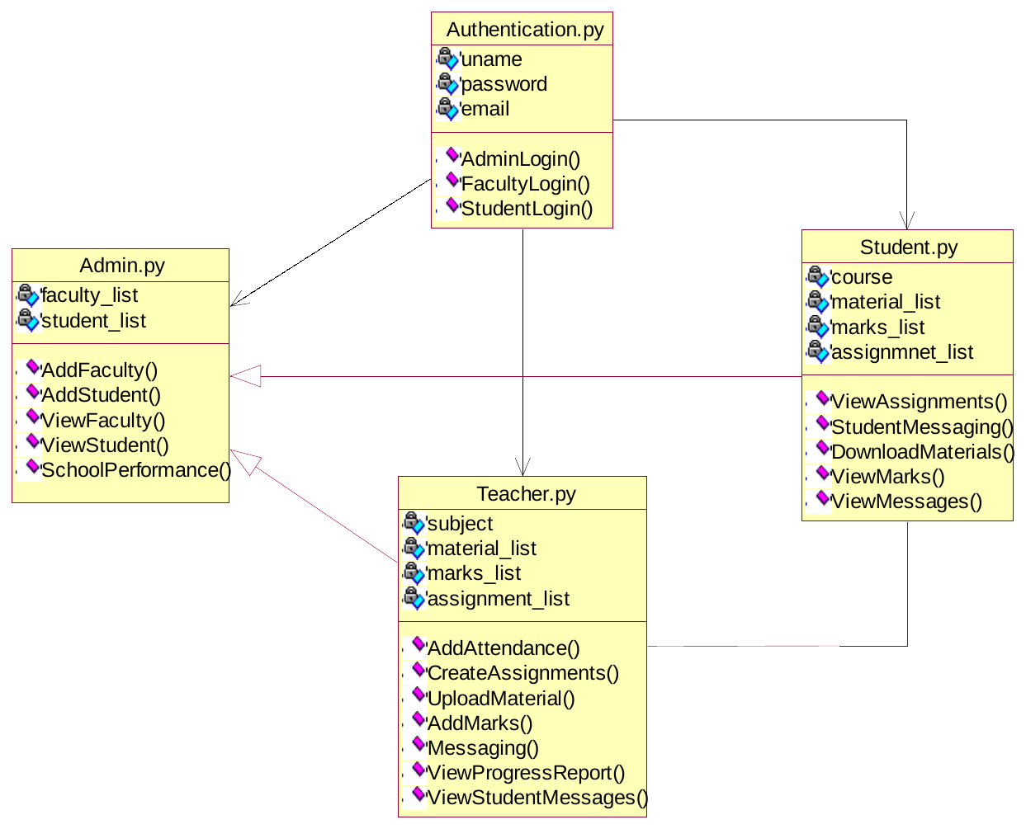
Fig 4.8 Class Diagram

4.3.2 Use Case Diagram
A use case diagram shows the users and how they interact with the system.
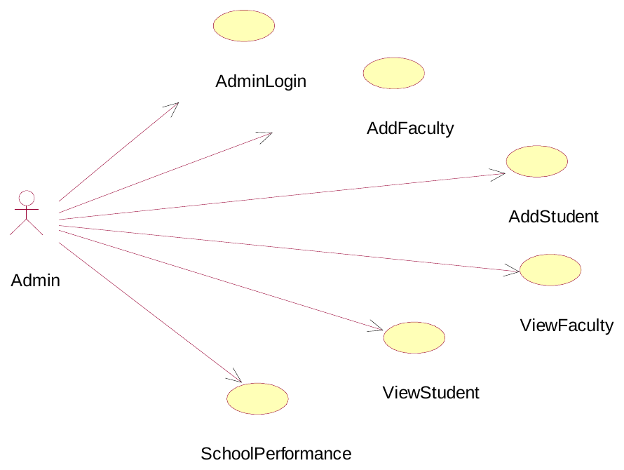
Fig 4.9 Use Case Diagram – Admin
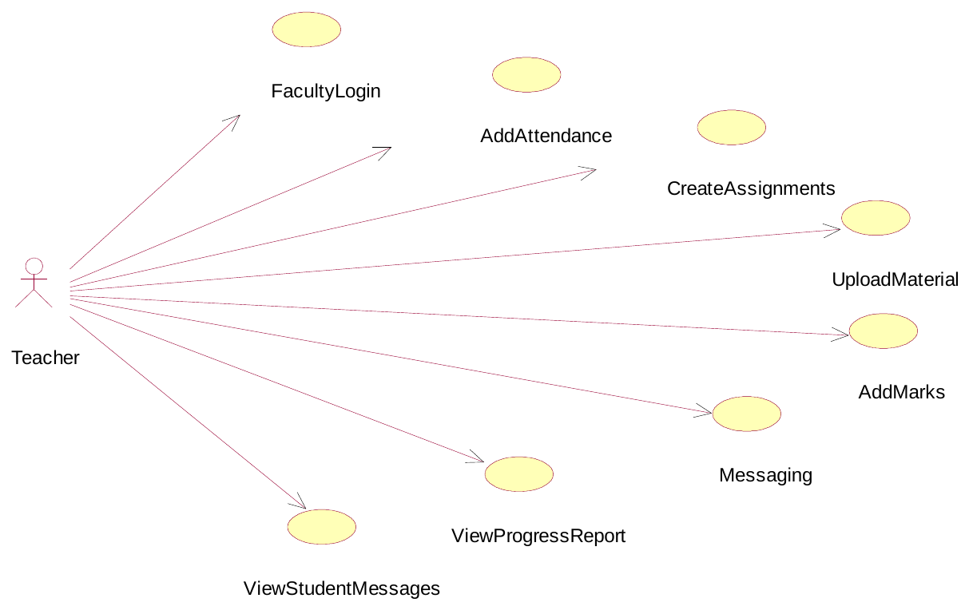
Fig 4.10 Use Case Diagram – Teacher
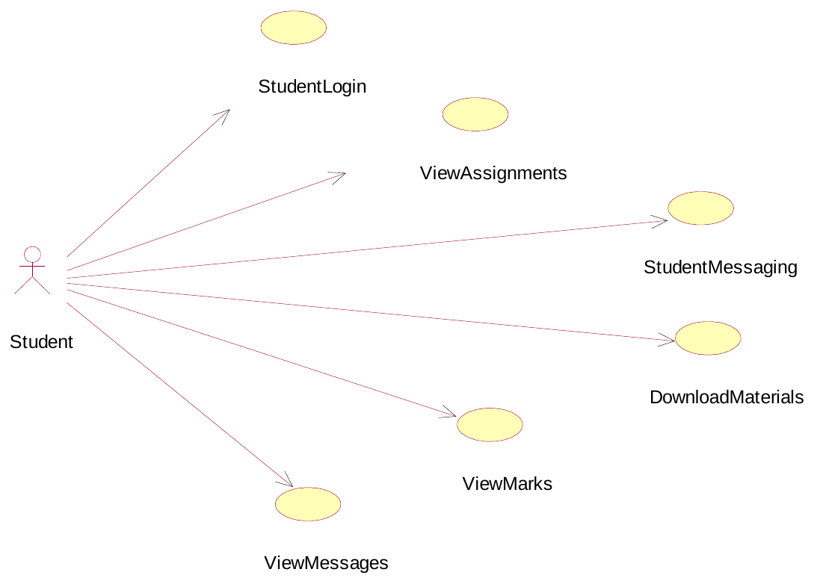
Fig 4.11 Use Case Diagram – Student

4.3.3 Sequence Diagram
A sequence diagram shows the order of interactions between objects.
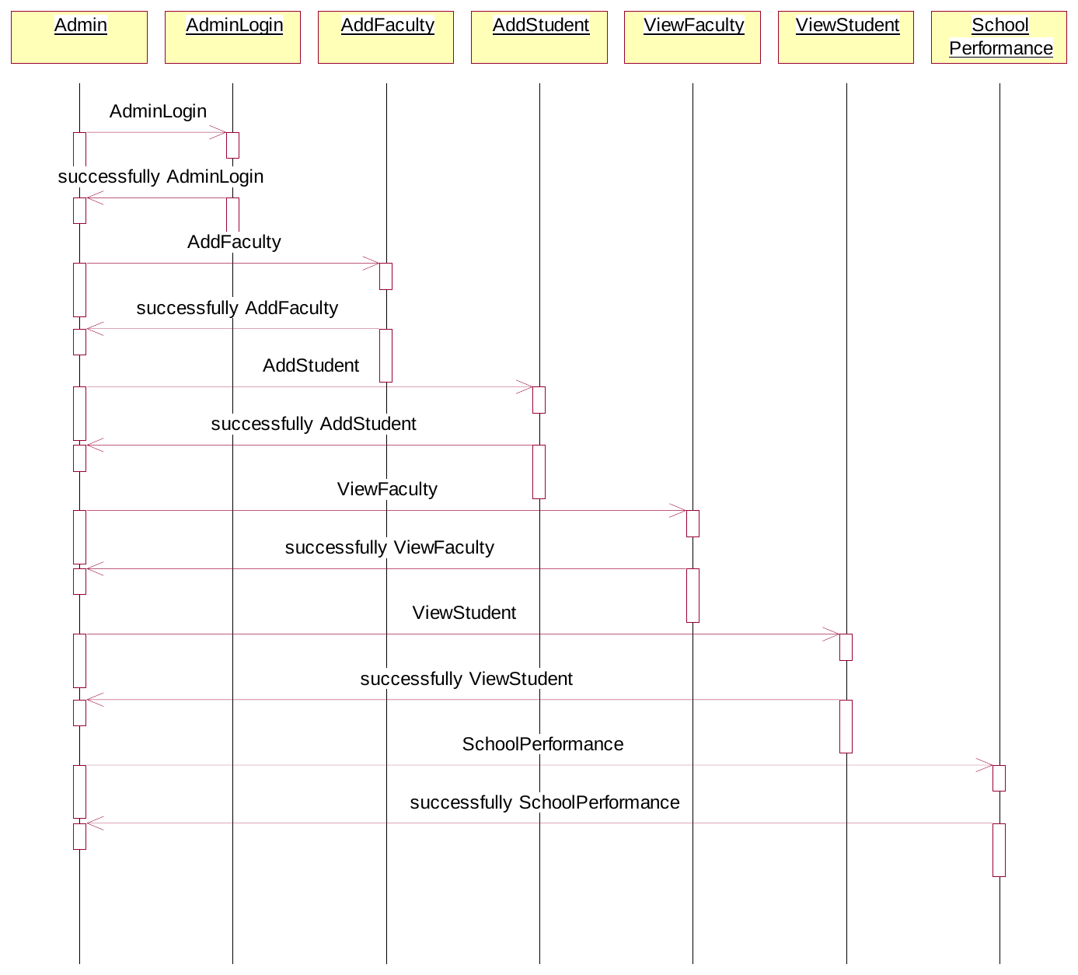
Fig 4.12 Sequence Diagram – Admin
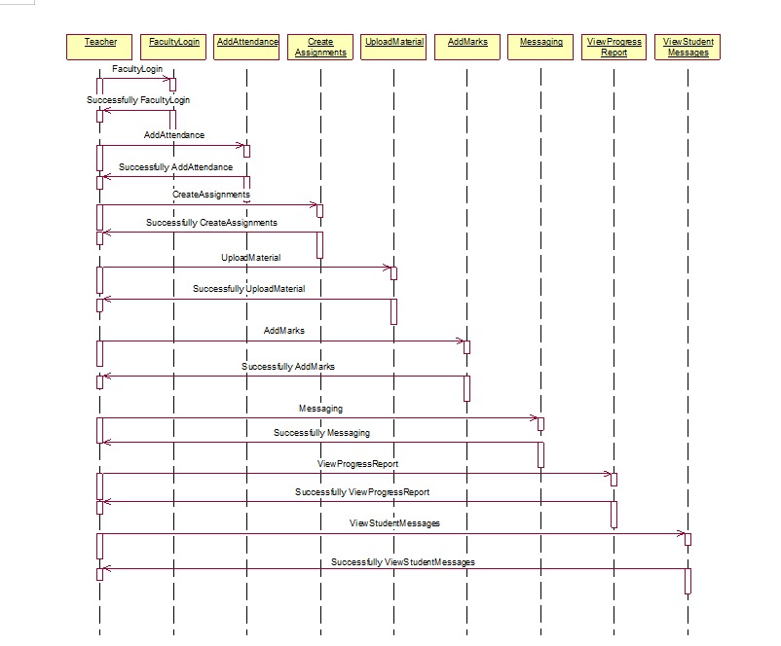
Fig 4.13 Sequence Diagram – Teacher
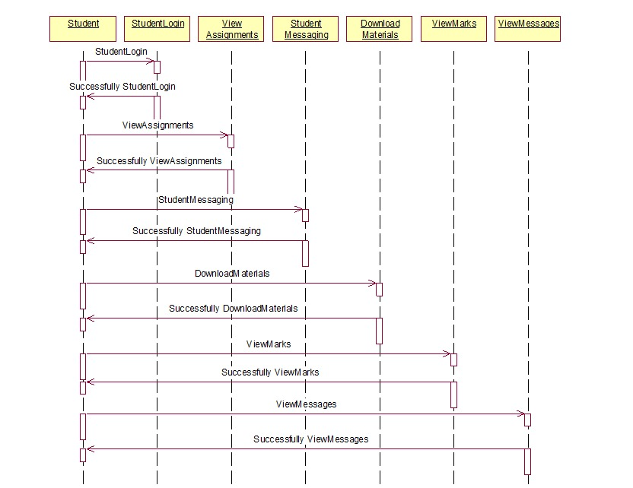
Fig 4.14 Sequence Diagram – Student

4.3.4 Collaboration Diagram
A collaboration diagram shows object interactions as sequenced messages.
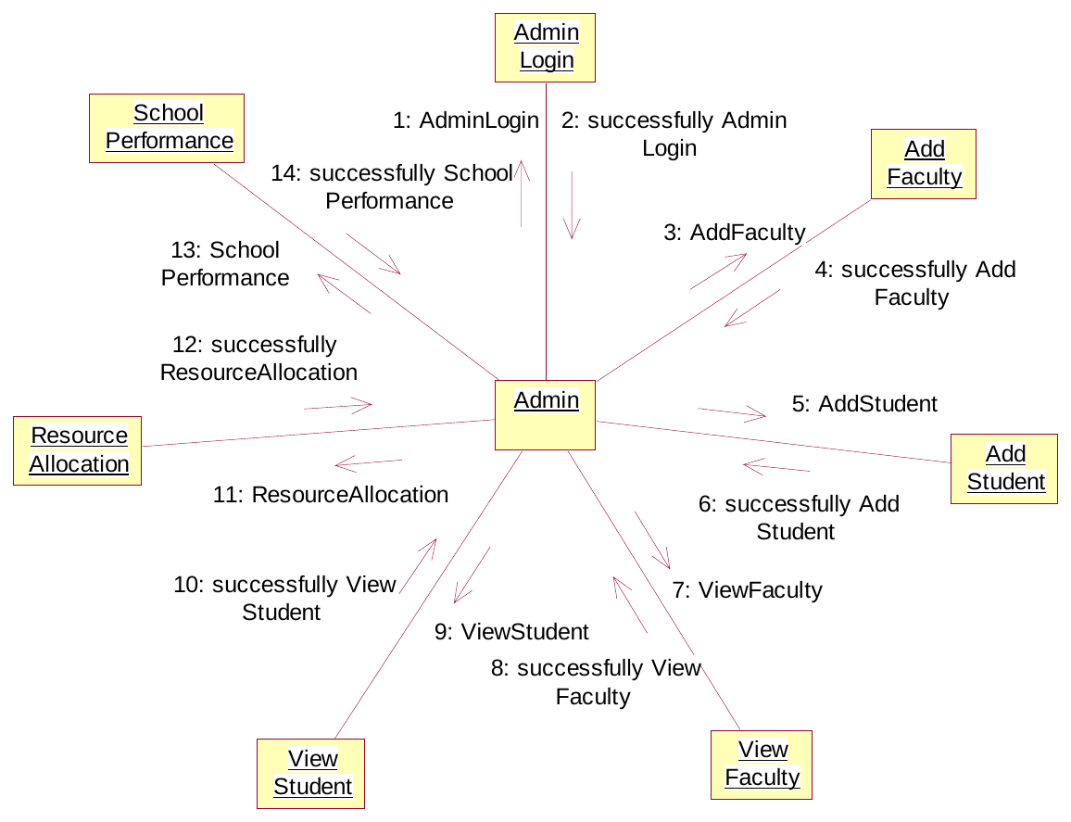
Fig 4.15 Collaboration Diagram – Admin
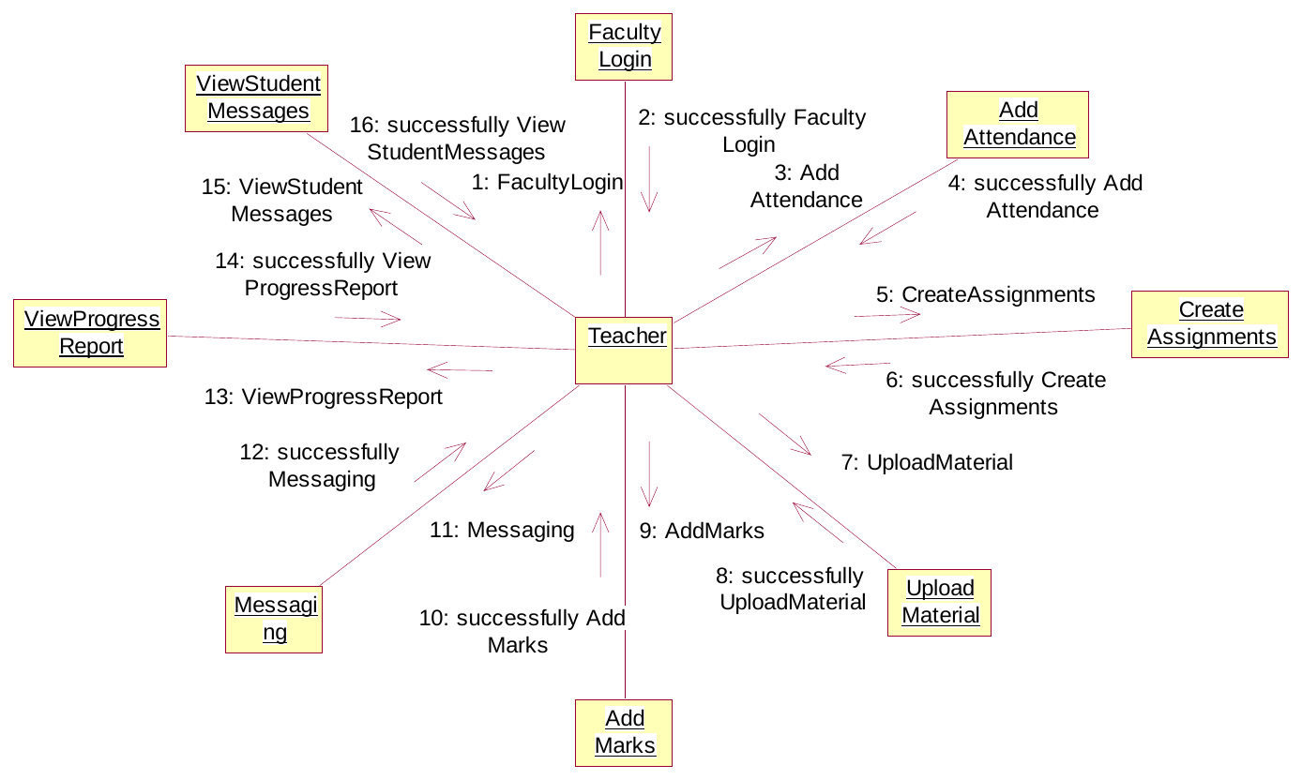
Fig 4.16 Collaboration Diagram – Teacher
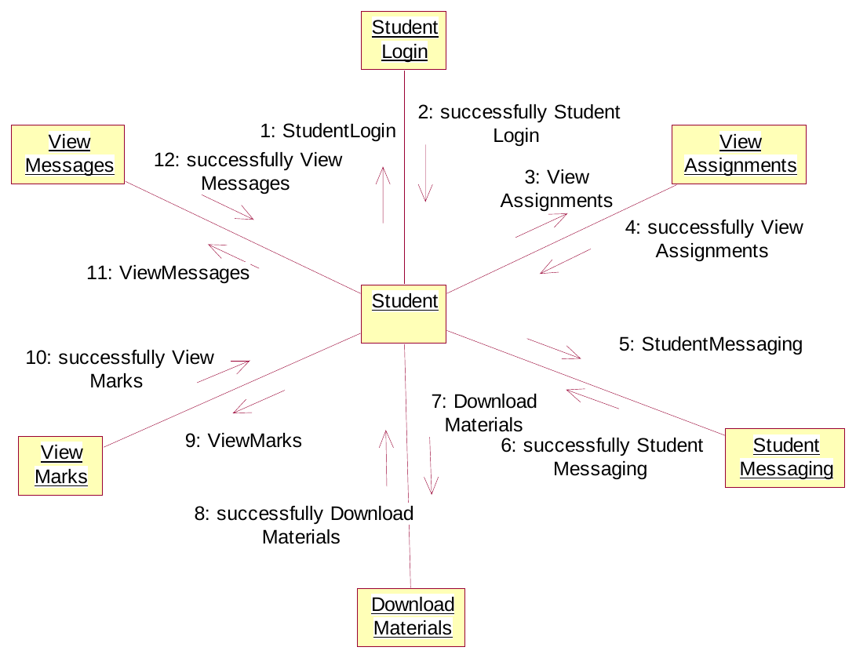
Fig 4.17 Collaboration Diagram – Student

4.3.5 Component Diagram
A component diagram shows how the software components are connected.
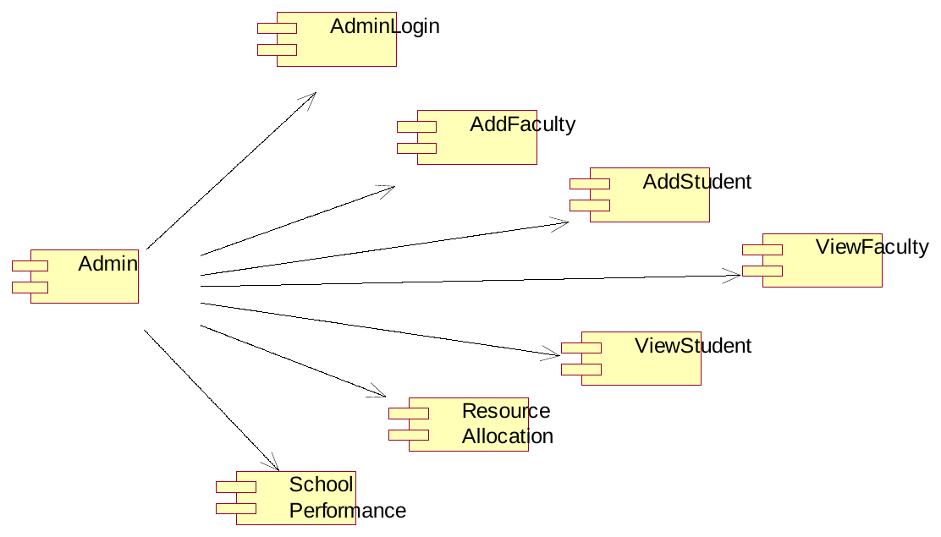
Fig 4.18 Component Diagram – Admin
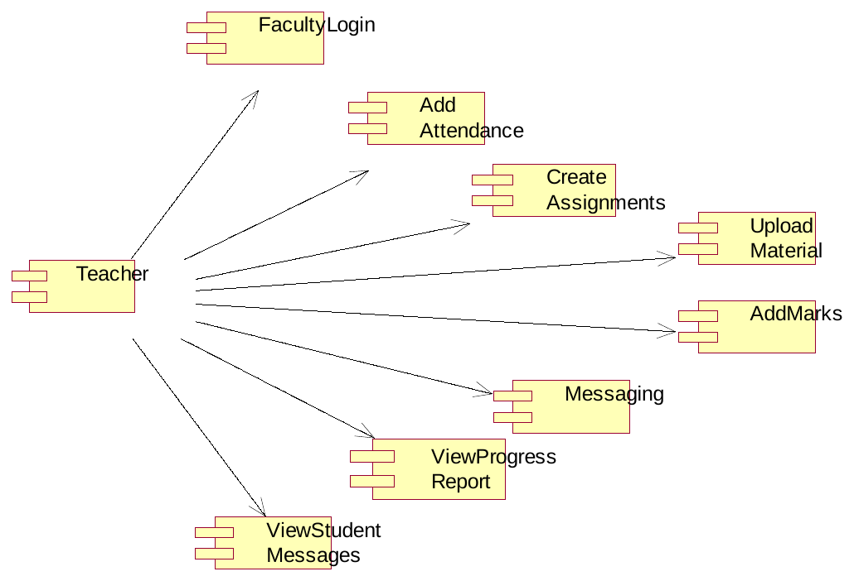
Fig 4.19 Component Diagram – Teacher
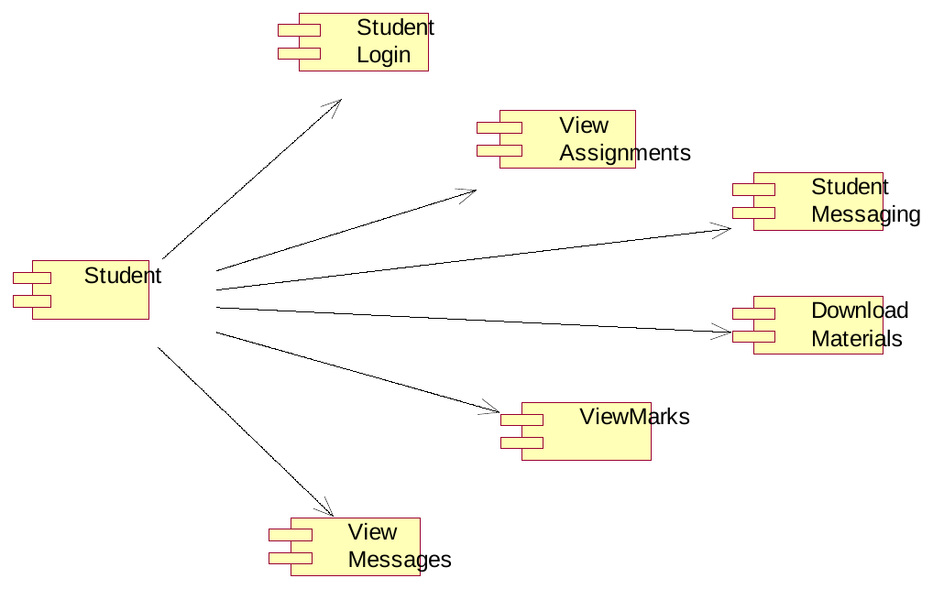
Fig 4.20 Component Diagram – Student

4.3.6 Deployment Diagram
A deployment diagram shows how software is deployed on hardware nodes.
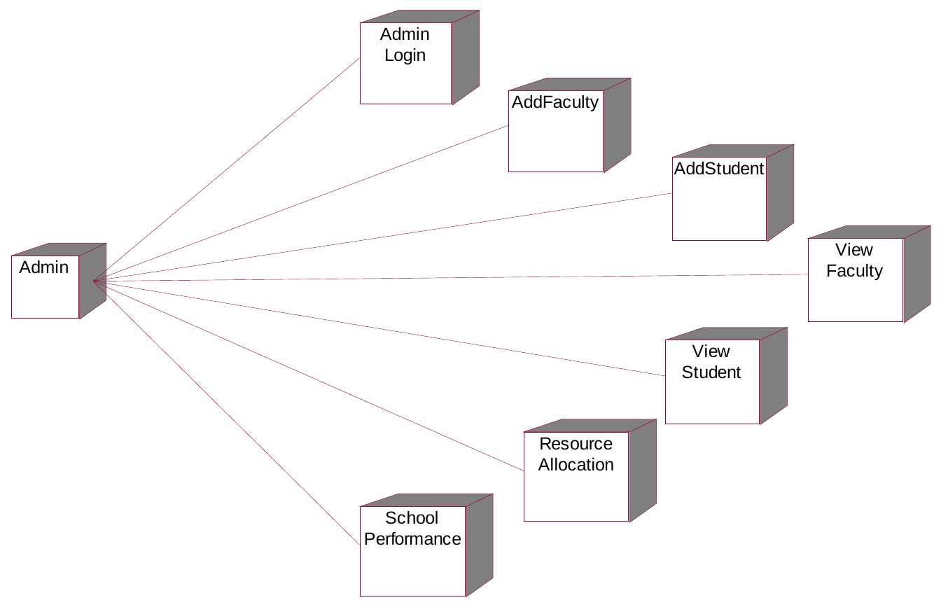
Fig 4.21 Deployment Diagram – Admin
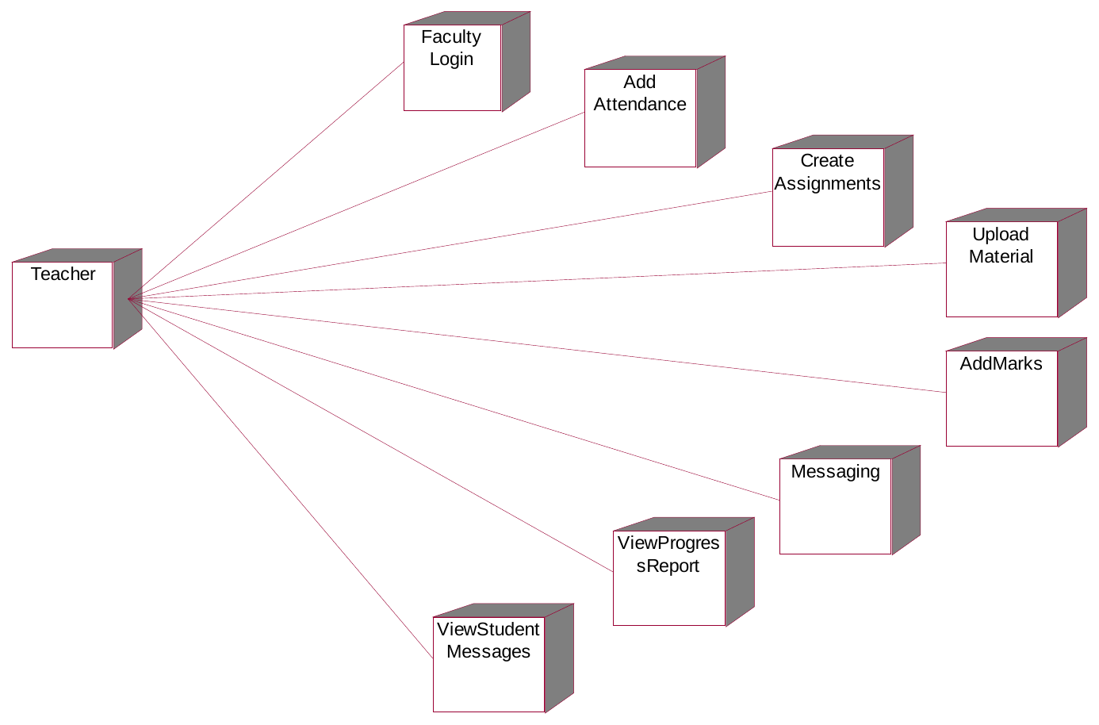
Fig 4.22 Deployment Diagram – Teacher
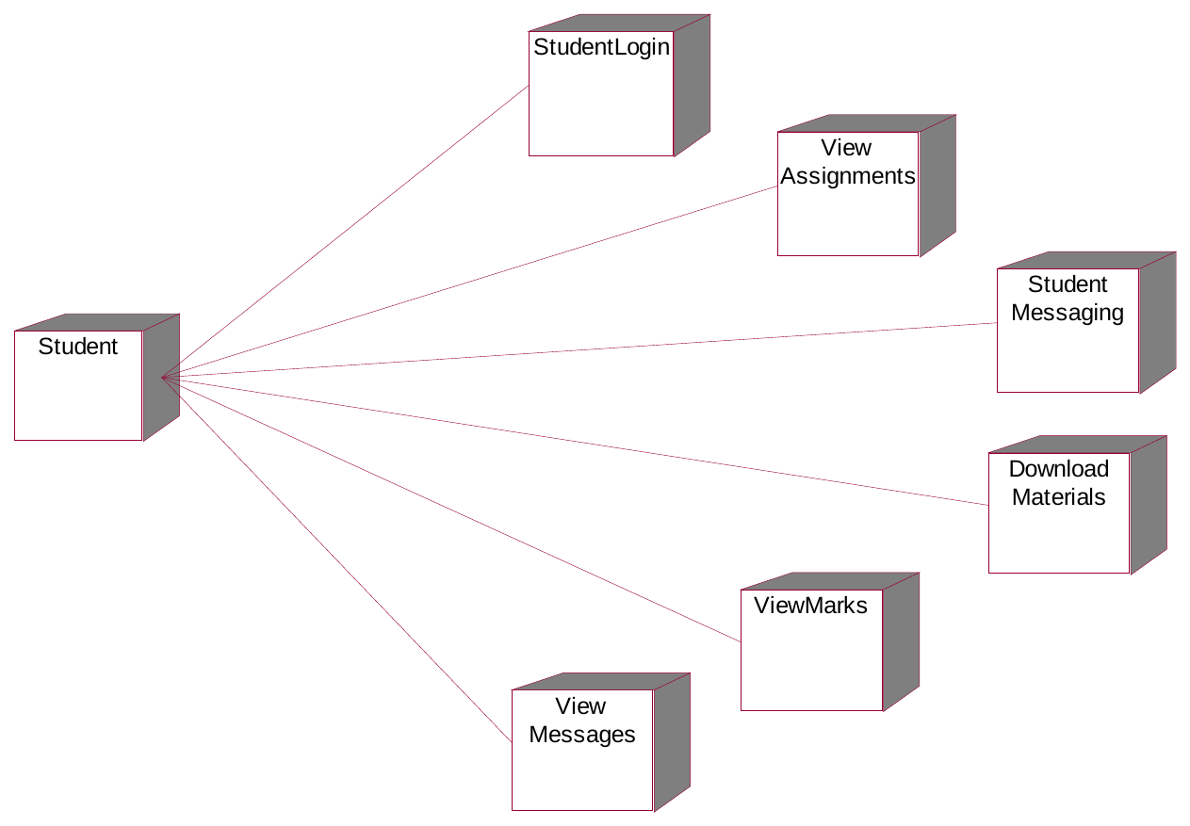
Fig 4.23 Deployment Diagram – Student

4.3.7 Activity Diagram
An activity diagram shows the flow of activities in the system.
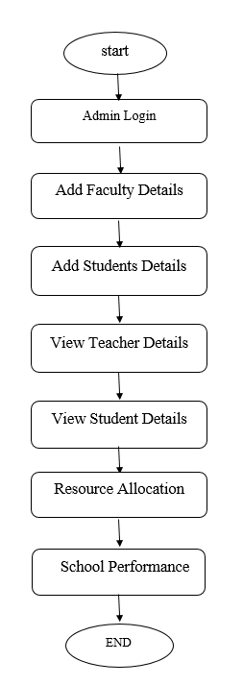
Fig 4.24 Activity Diagram – Admin
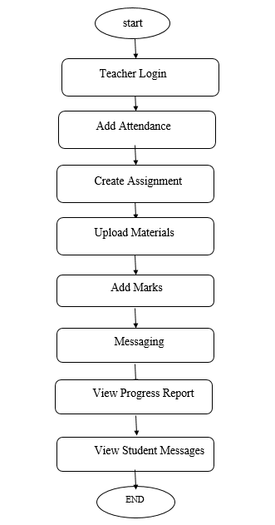
Fig 4.25 Activity Diagram – Teacher
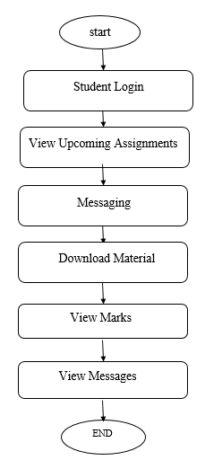
Fig 4.26 Activity Diagram – Student

4.3.8 Data Flow Diagram
A DFD shows how data flows through the system as inputs, processes and outputs.
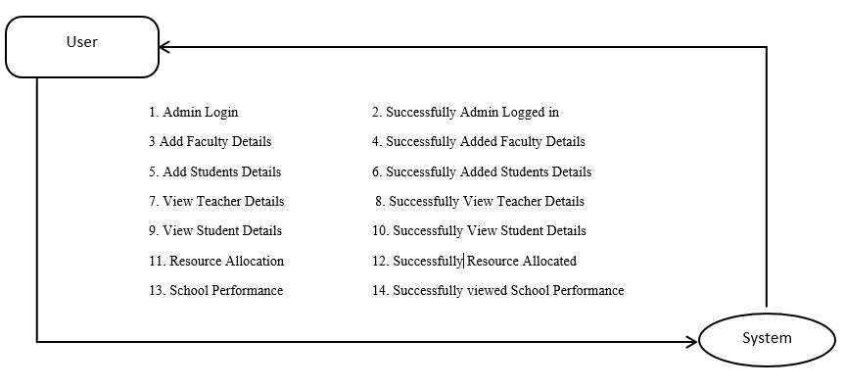
Fig 4.27 Data Flow Diagram – Admin
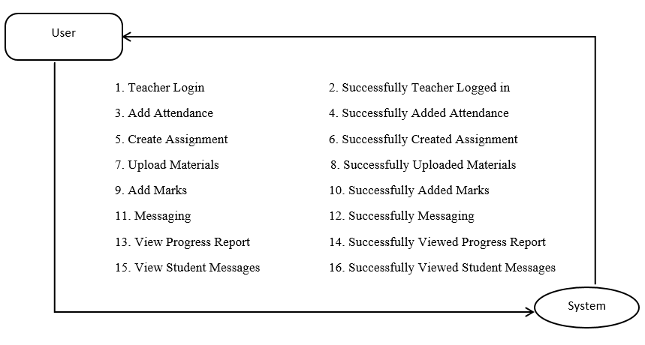
Fig 4.28 Data Flow Diagram – Teacher
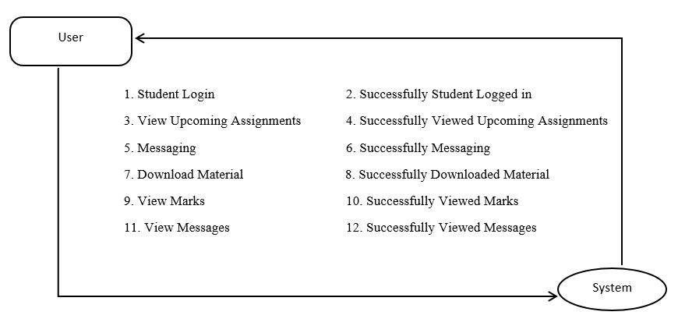
Fig 4.29 Data Flow Diagram – Student

CHAPTER-5
INPUT AND OUTPUT DESIGN
Input design defines how data enters the portal, and output design defines how results are shown to the users. Both are kept simple, role-based and easy to use.

5.1 Input Design
All inputs are collected through web forms that validate required fields and data types to avoid errors.
- Login: username and password for Admin, Teacher and Student.
- Admin: faculty details and student details.
- Teacher: attendance, subject-wise marks, assignment details, study material and messages.
- Student: doubts and messages to the teacher.
- ML input: subject-wise marks of the student, used for performance prediction.

5.2 Output Design
Outputs are shown on role-based dashboards as tables, lists and messages.
- Admin: lists of faculty and students, and the school performance report based on average grades.
- Teacher: progress report with marks and ML-predicted feedback, and student messages.
- Student: marks with predicted feedback (Good, Fair or Poor), upcoming assignments, downloadable material and teacher messages.
- Email: messages sent by the teacher are delivered to the parent's email.
Table 5.1 Role-wise Inputs and Outputs
Role | Input | Output
Admin | Login, faculty and student details | Faculty and student lists, school performance
Teacher | Attendance, marks, assignments, materials, messages | Progress report with predicted feedback, student messages
Student | Login, doubts and messages | Marks with feedback, assignments, materials, messages

CHAPTER-6
SOFTWARE ENVIRONMENT
The portal is developed using the following software tools and technologies. Hardware and operating system requirements are given in Tables 3.1 and 3.2.
- Python: main programming language for the web application and the machine learning models.
- Django: web framework based on the Model-View-Template (MVT) pattern, providing authentication, an admin interface, ORM, URL routing and built-in security.
- XGBoost and Naïve Bayes: machine learning models for academic performance prediction, with Pandas and NumPy for data handling.
- Database: relational database (Django's default SQLite) storing users, attendance, marks, assignments and messages.
- Front end: HTML, CSS and JavaScript for the Admin, Teacher and Student dashboards.
- Email (SMTP): used to send teacher messages to the parent's email.

CHAPTER-7
SYSTEM TESTING AND RESULTS DISCUSSION

7.1 System Testing
System testing checks that the portal works as expected. The following levels of testing are carried out.
- Unit testing: each module such as login, attendance, marks, assignments and messaging is tested separately.
- Integration testing: the modules are combined and tested for correct data flow between them and the ML models.
- Functional testing: the features of the Admin, Teacher and Student dashboards are tested against the requirements.
- Acceptance testing: the complete portal is checked to confirm that it meets user needs.

7.1.1 System Testing Table
Table 7.1 System Test Cases
Test ID | Test Case | Expected Result | Status
T1 | Login with valid credentials | Role dashboard opens | Pass
T2 | Login with invalid credentials | Error message is shown | Pass
T3 | Admin adds faculty / student | Record is saved and listed | Pass
T4 | Teacher adds attendance and marks | Data is stored successfully | Pass
T5 | Teacher uploads study material | Student can download it | Pass
T6 | Student views marks | Marks and ML feedback are displayed | Pass
T7 | Teacher sends a message | Message reaches student and parent email | Pass

7.2 Results Discussion
Naïve Bayes and XGBoost were trained on historical student marks data to classify performance as Good, Fair or Poor. XGBoost performed better than Naïve Bayes and met the target accuracy of over 93%. The test cases confirm that the Admin, Teacher and Student modules work correctly.

CHAPTER-8
CONCLUSION
Skills and knowledge can be transferred by network enabled computers called student portal. Since new technologies are commonly thought to make a big difference in education, many universities have adopted portal of student to support teaching and learning processes. Most portal applications allow for students to delivery and tracking of e-learning courses, content, testing; and the management of instructor-led training classes. In this project, we analyze and design a portal site for the university. So that the students save time and effort and the educational process is proceeded easily and easily. This system site has a relationship with teachers and students and is concerned with the educational materials for students and each article linked to educational references. So that all related subjects of education on the site and reach the student easily. And this site contributes to raise the perception of the student so as to extend everything needed during the process. The site receive all references and daily lectures provided to students. With all the lectures. Therefore, the student only has to enter the site by logging in and viewing the study sites and can make a download of the contents on the site. This process saved the students time and effort and the learning process goes smoothly and helper. Exchange of educational experiences between individuals through the means of learning. Developing the skills and abilities of students and build their personalities to prepare a generation capable of communicating with others and to interact with them.

CHAPTER-9
FUTURE ENHANCEMENTS
- Deep Learning: The current Naïve Bayes and XGBoost models can be extended with LSTM or GRU networks. These models learn from a student’s marks over several terms rather than a single snapshot, so predictions can be more accurate and can follow how performance changes over time.
- Personalized Pathways: Based on the predicted performance, the portal can generate custom study plans for each student. These can suggest weak subjects to revise, recommend study material from the uploaded content, and set targets for the next exam.
- Engagement Analytics: The portal can track student activity such as logins, material downloads, assignment submissions and attendance. A drop in engagement can flag at-risk students early, so teachers can step in before marks are affected.
- Mobile Apps: Android and iOS apps can be added so students, teachers and parents can use the portal on their phones. They would provide push notifications for assignments, marks and messages, and offline access to downloaded study material.
- Additional Features: The portal can later add parent login, online assessments, and automatic alerts to parents when performance falls into the Poor category.

REFERENCES
[1] A. K. Prewar, T. D. Sofianti and d. Y. Indrayadi (2015), Developing E-Learning System to Support Teaching and Learning Activities Using DSDM Approach, Performa (2015) pp.41-52
[2] M Kura (2013), E-learning System Design by Learning Management System (LMS) focusing on Emotional Aspects using Biological Signals pp.10-15
[3] B. Kwofie,(2015), E-Learning Implementation in Higher Education Institutions. Department of Electronic Systems, Aalborg University pp.44-66
[4] K Thuraya (2015), Improving the Effectiveness of E-Learning Implementation in the School ofEngineering at Tripoli University. Doctoral thesis, University of Huddersfiel
[5] O Deperlioglu (2011), development of a relational database for learning management systems pp.17-25
[6] N Maharashtra (2019), PCE Staff/Student Portal https://www.pce.ac.in/students/pce-studentportal/
[7] M Gupta and S arsden (2018), Lessons Learned from Implementing E-Learning for the Education of Health Professionals in Resource-Constrained Countries pp.12- 30
[8] G Musca and Andrei and Lucian (2018), No.59A, Iasi700050, Romania pp.45-49
[9] S Hadjerroui (2017) Applying a System Development Approach to Translate Educational Requirements into ELearning pp.11-33
[10] A allaIdris and Y Osman (2017), Implementation of Elearning in The University of Gezira Barriers and Opportunities pp.7-22
[11] G. Daniel, "Emotional Intelligence: Why It Can Matter More Than IQ", New York: Bantam, 1995.
[12] J. A. Russell, "A circumflex model of affect" in Journal of Personality and Social Psychology, 39, pp. 1161-1178, 1980
[13] C, K.-H., Yoo,H.-J.& Kim, H.-S.(2005). A process-driven e-learning content organization model. Fourth Annual ACIS International Conference on Computer and Information Science. 328 - 333. ICIS 2005: Jeju Island, South Korea.

